Here is a step by step walk-through for the Tax Credit Process (with pictures):

- Visit https://az-tucson.intouchreceipting.com/ and login using (student matric #) as the username and (student last name) as the password. Please note it is case sensitive.
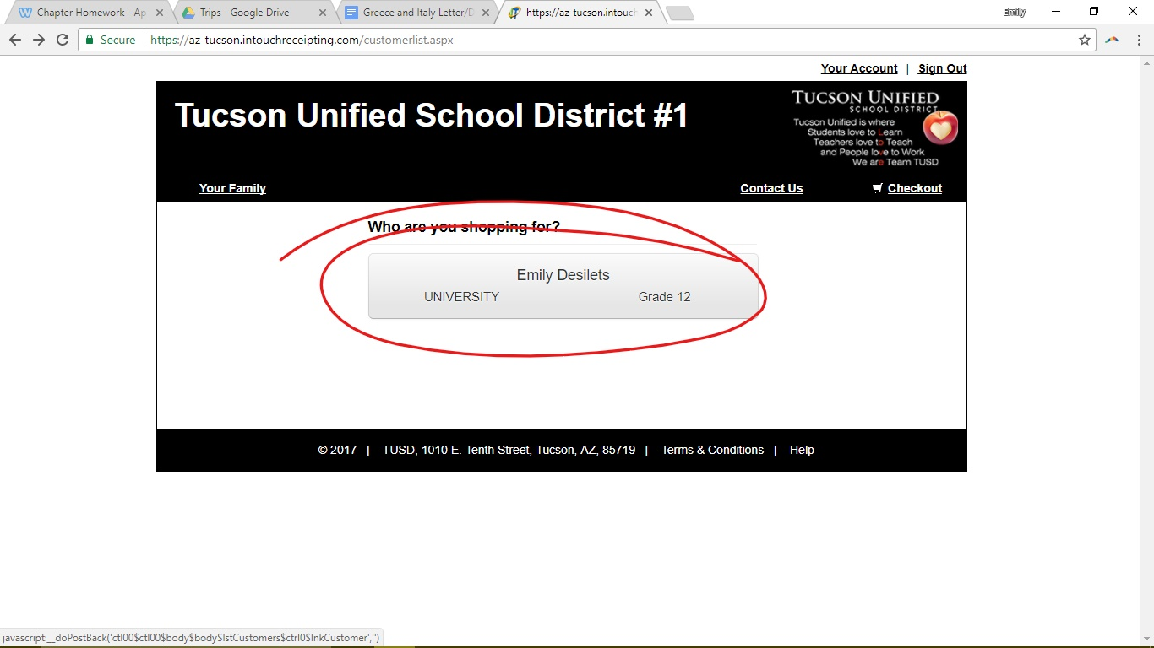
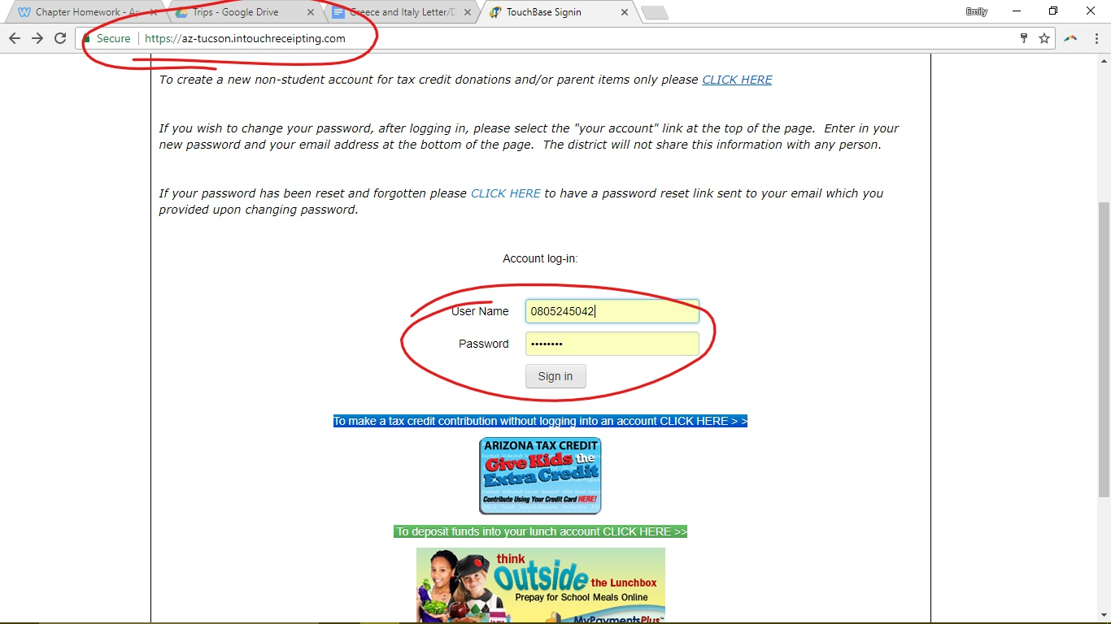
- Next Click on the option showing my name: “Emily Desilets”
And under “shop” click on “items at student’s school”
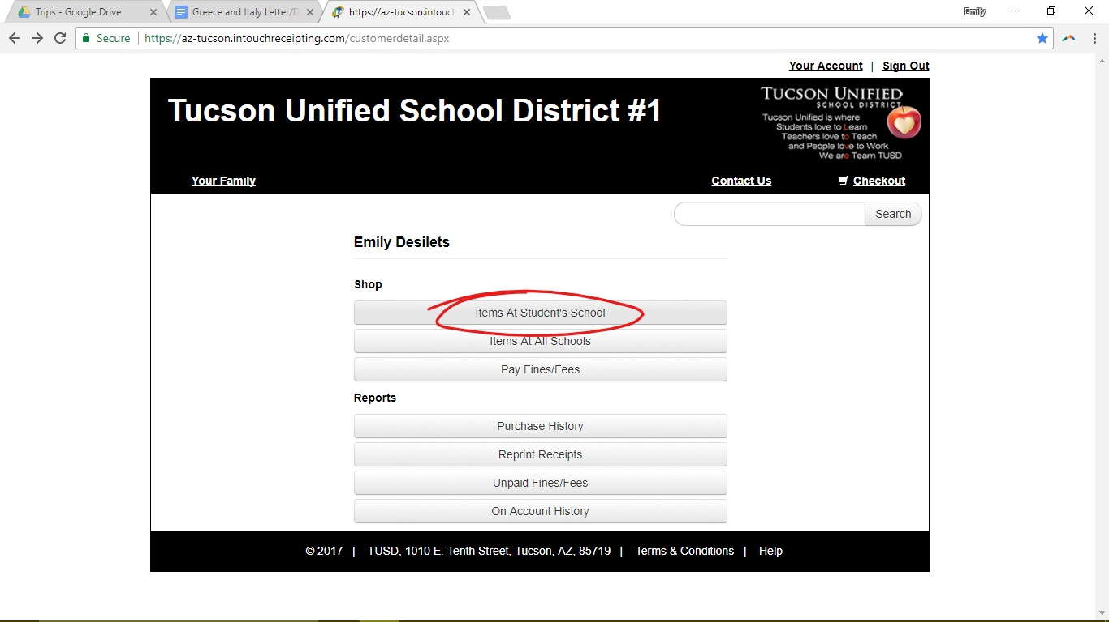
- On the following screen, first click the link “High School”,
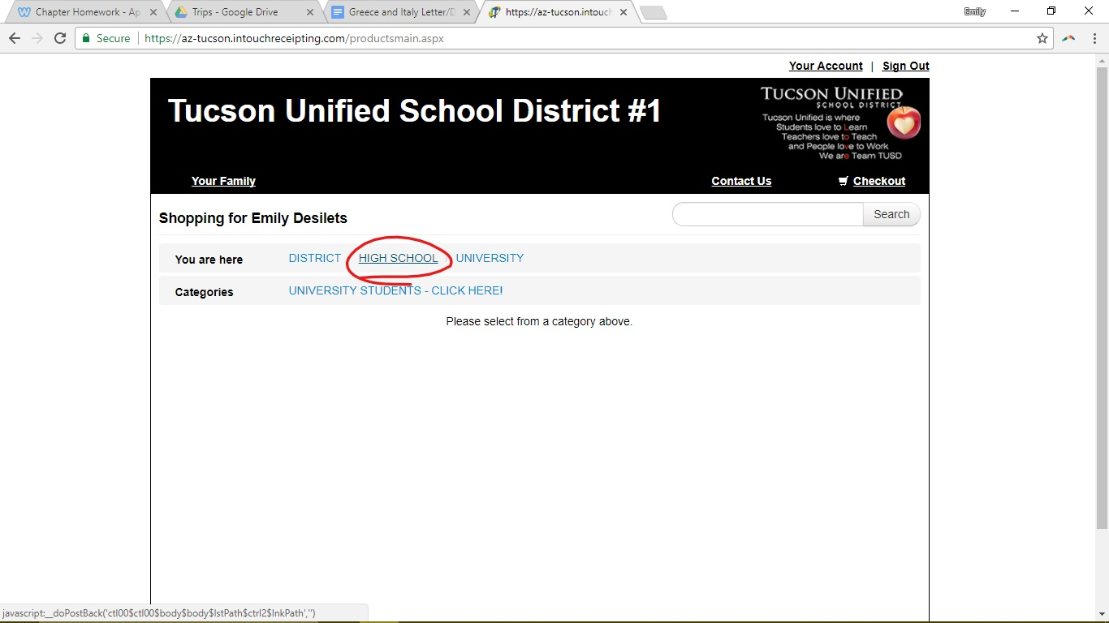

- And then choose “Rincon University”
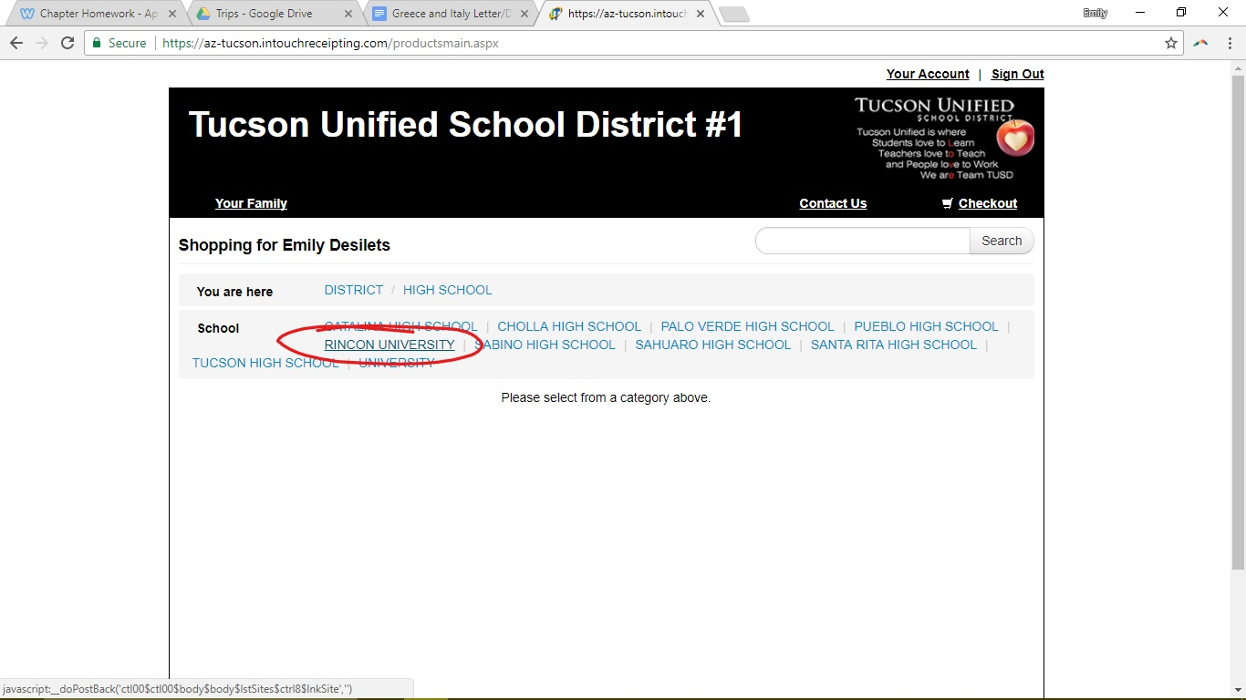
- The next page will have a series of categories. Of these, click on “Tax Credit Contributions”
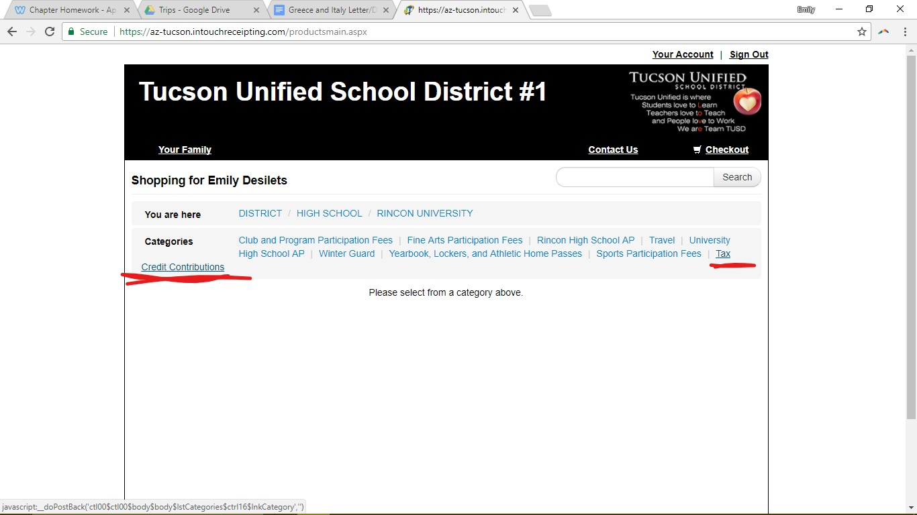

- You will arrive on the following page:
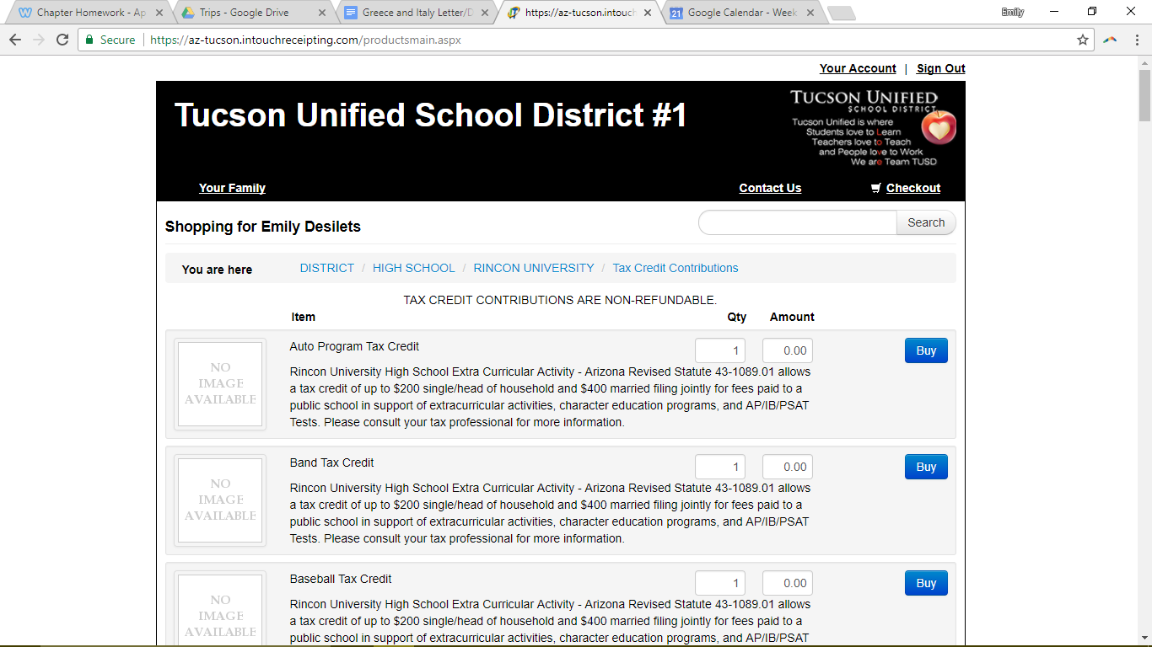
- Please scroll down to the bottom and find “Travel Program University High Tax”. This is where you will be contributing your money. To do so, enter the quantity of donations you are making, and the amount of money for each. Then click “Buy”.
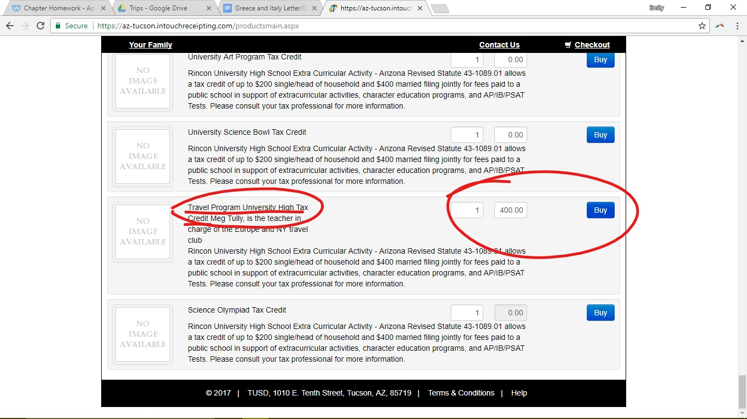
Please remember, individuals can donate a TOTAL of $200 in tax credits, and married couples a TOTAL of $400. This means if you donate to another program as well, it has to add up to that amount. DO NOT GO OVER THE LIMIT IT CAN COST ME THIS TRIP.
- When you press buy, it will go into checkout, which you can see the option for when you scroll back to the top. Click this option to proceed to completion.
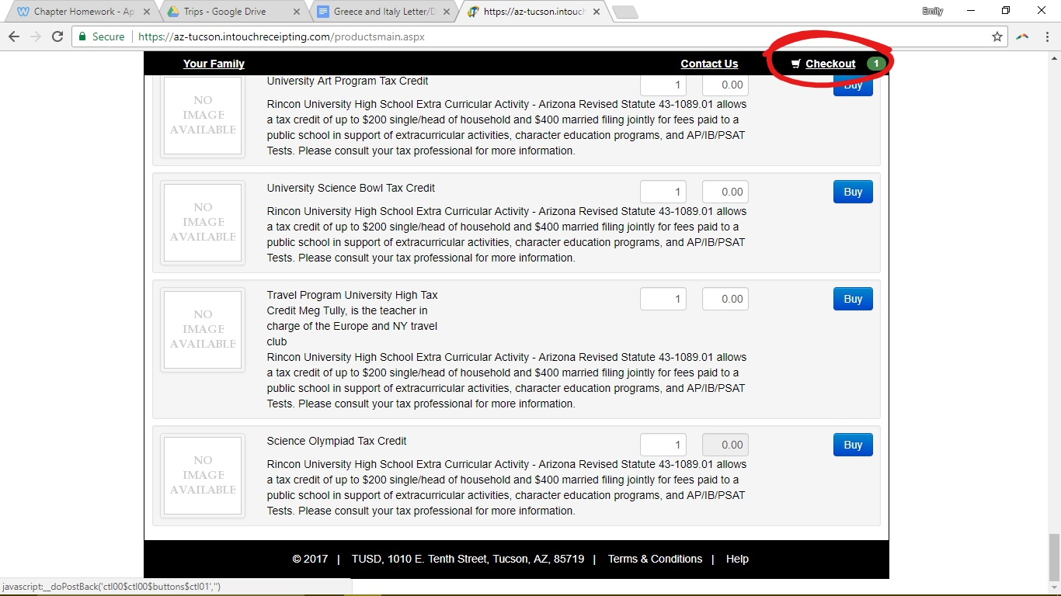
- When you reach checkout, there will be an option at the bottom after the totalling of your payment that says “Checkout Step 1: Additional Info”. Click this.
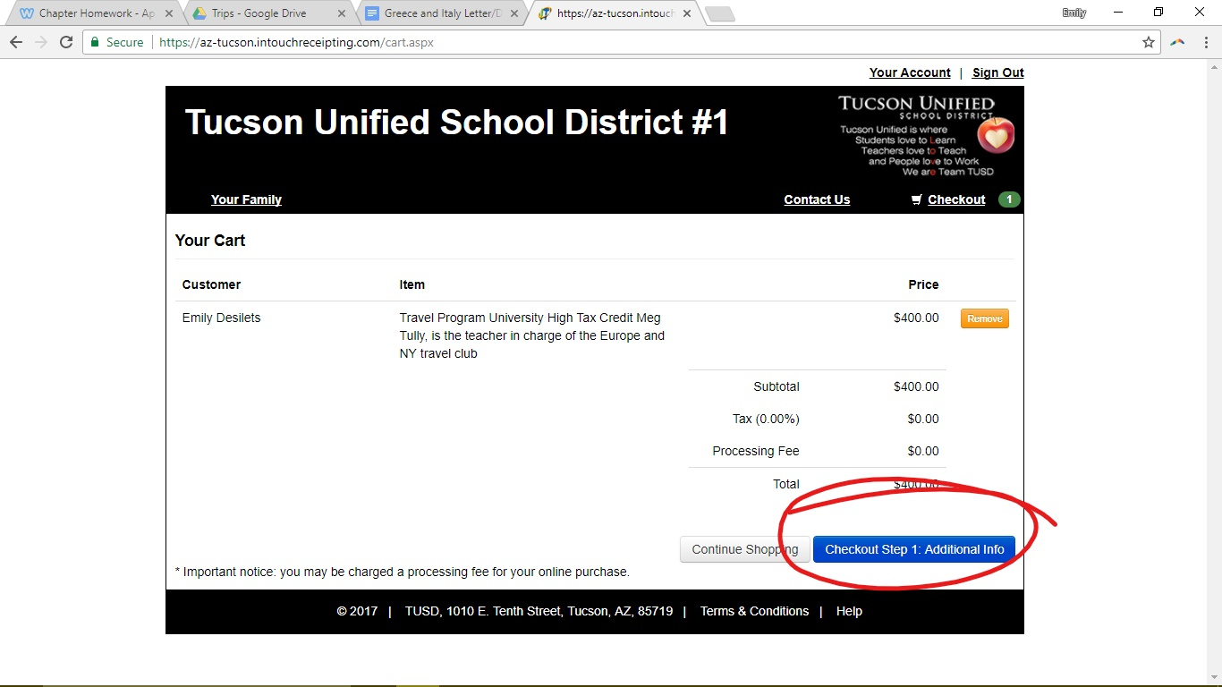

- This should bring you to a page asking for your first and last name, and address including state, city, and zipcode. Please fill out all of this information and continue.
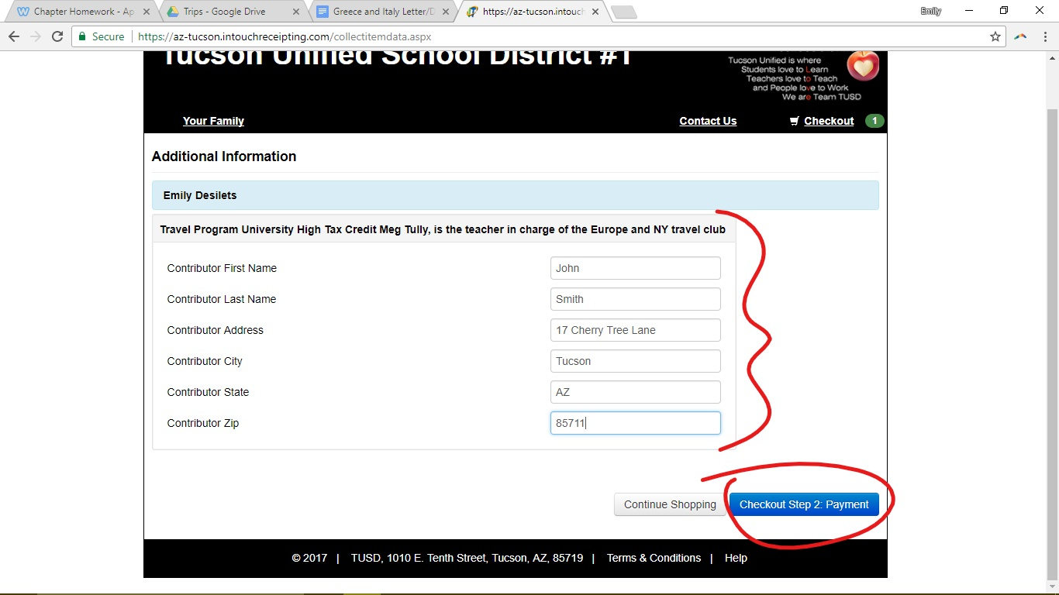
- We’re almost done! Fill out your credit card info and press Pay Now!
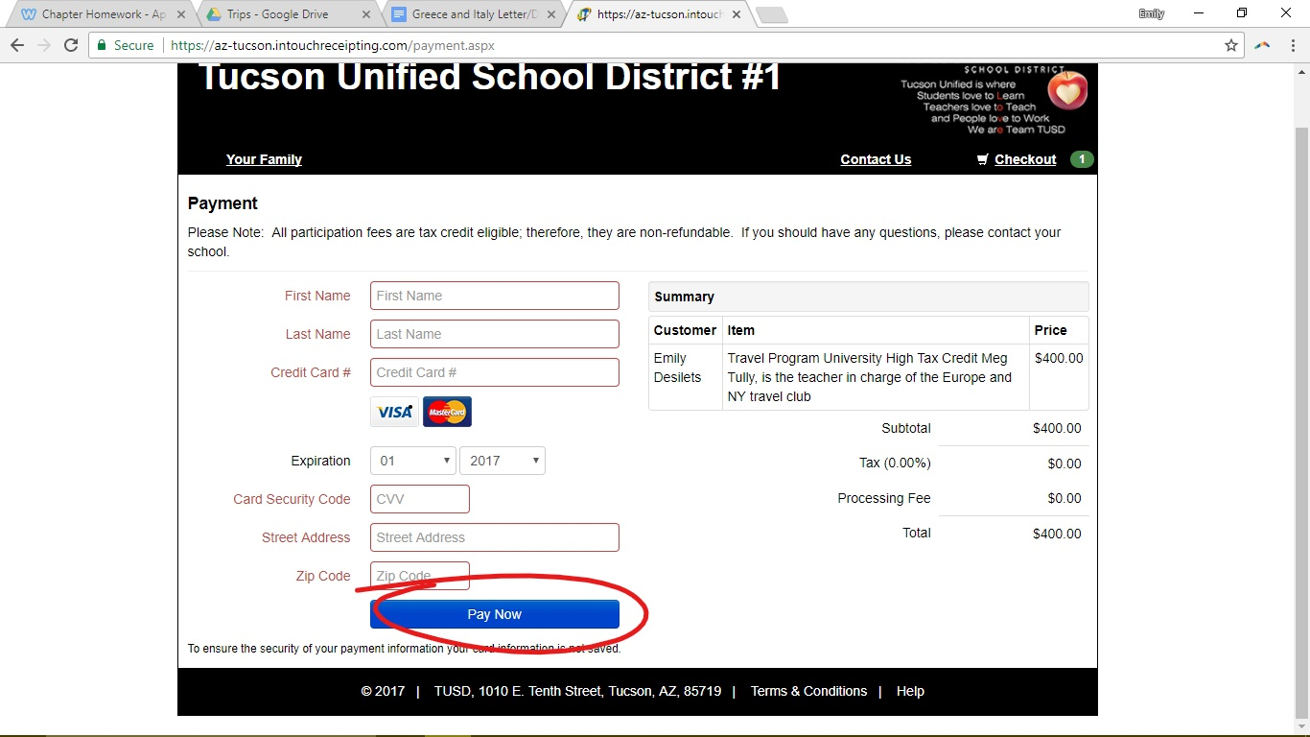

- Lastly! You should have a receipt provided to you that looks a lot like this:
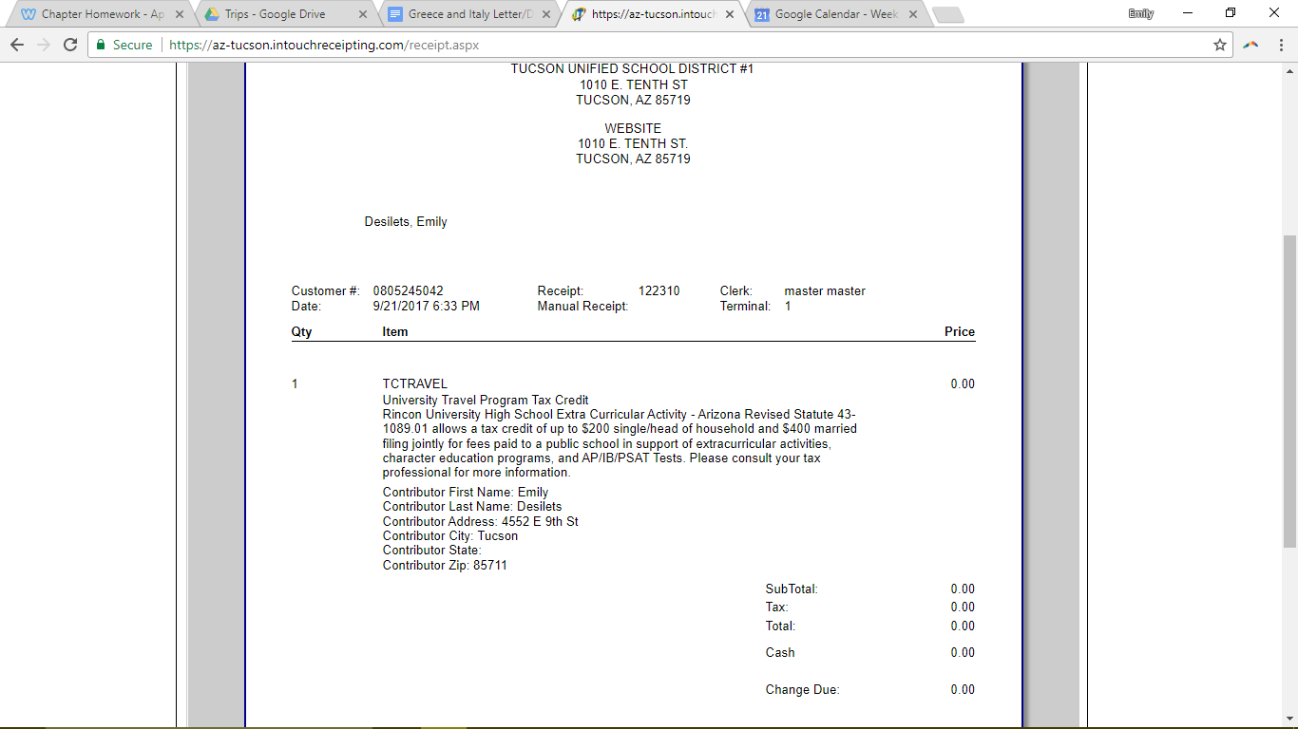
It must be emailed to me (emilydesilets16@gmail.com) so that I can give it to the leader of the trip, who organizes the payments and makes sure they are counted towards my trip on time. To send me this receipt, simply download it as a PDF by selecting (Acrobat (PDF) File) under “Export to selected File” and then pressing the link next to that saying “Export”. This will download the receipt as a PDF so you can attach it in an email and send it my way.
