- Visit https://az-tucson.intouchreceipting.com/ and login using (student matric #) as the username and (student last name) as the password. Please note it is case sensitive.
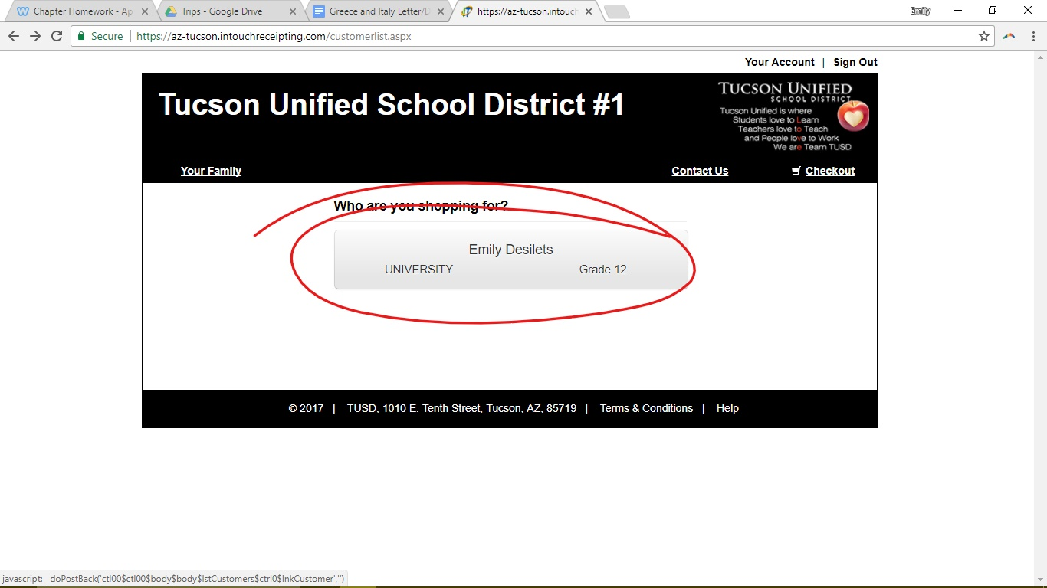
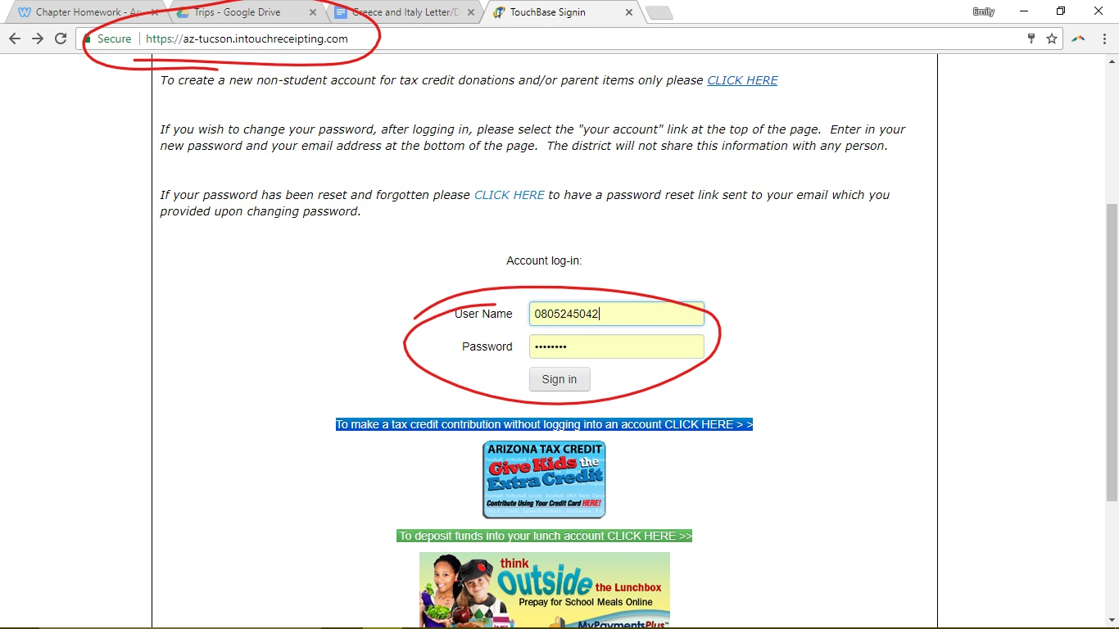
- Next Click on the option showing my name: “Emily Desilets”

And under “shop” click on “items at student’s school”
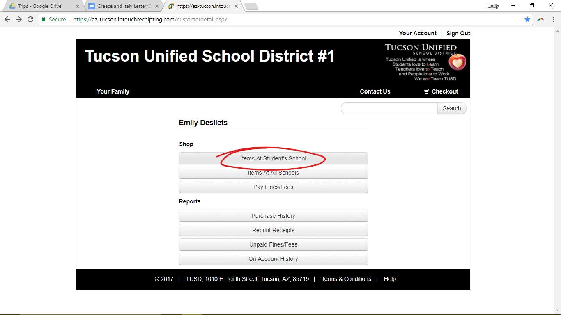
- On the following screen, first click the link “High School”,
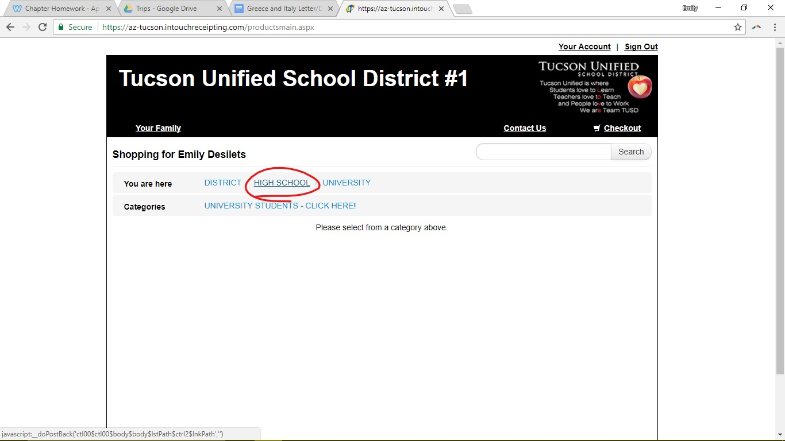

And then choose “Rincon University”
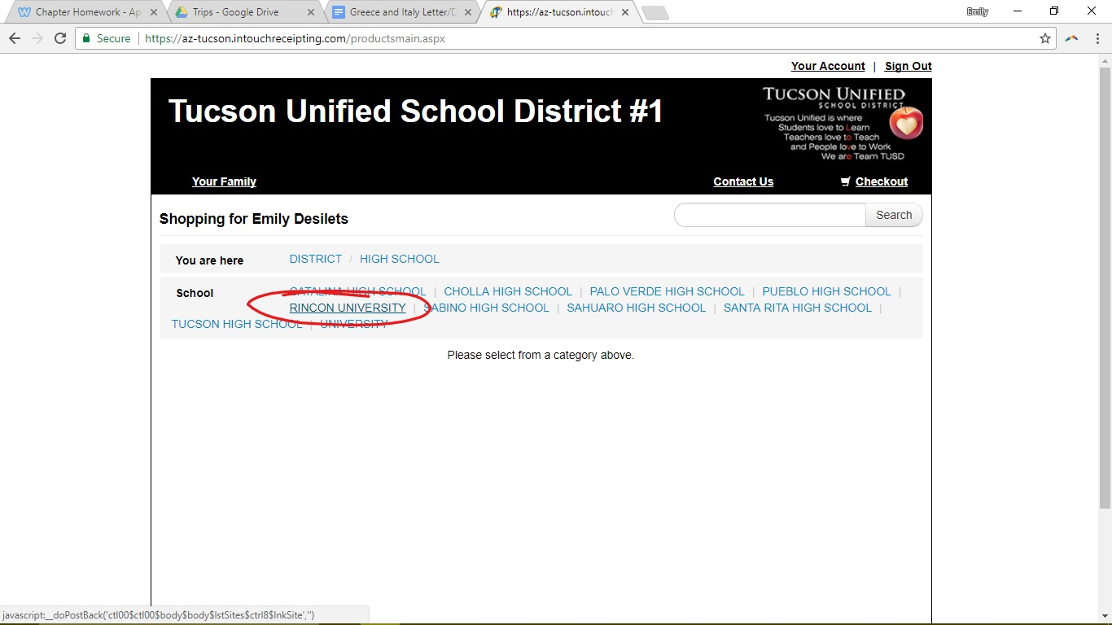
5) Click “Student Travel Clubs for RUHS”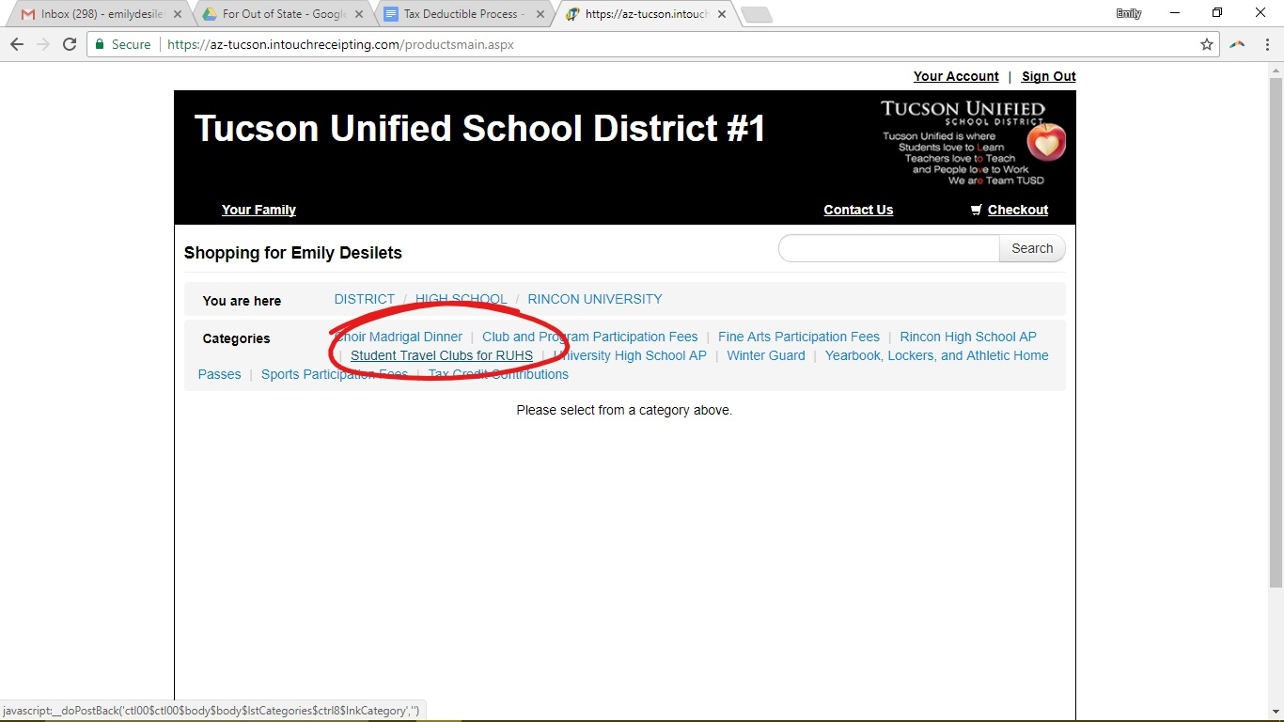

6) Scroll Down to “University High School Travel Club” and enter the amount of money you would like to donate in the farther right box. Then click the blue “Buy” button.
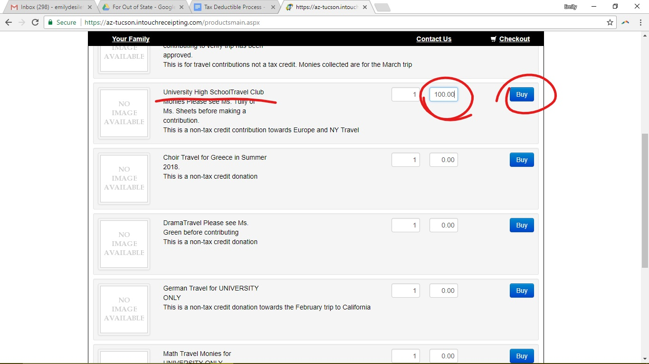
With tax deductions, you have no limit to how much you can donate, so please feel free to give what you can.

7) After clicking the “Buy” button, return to the top of the screen and select “Checkout” in the top right hand corner.
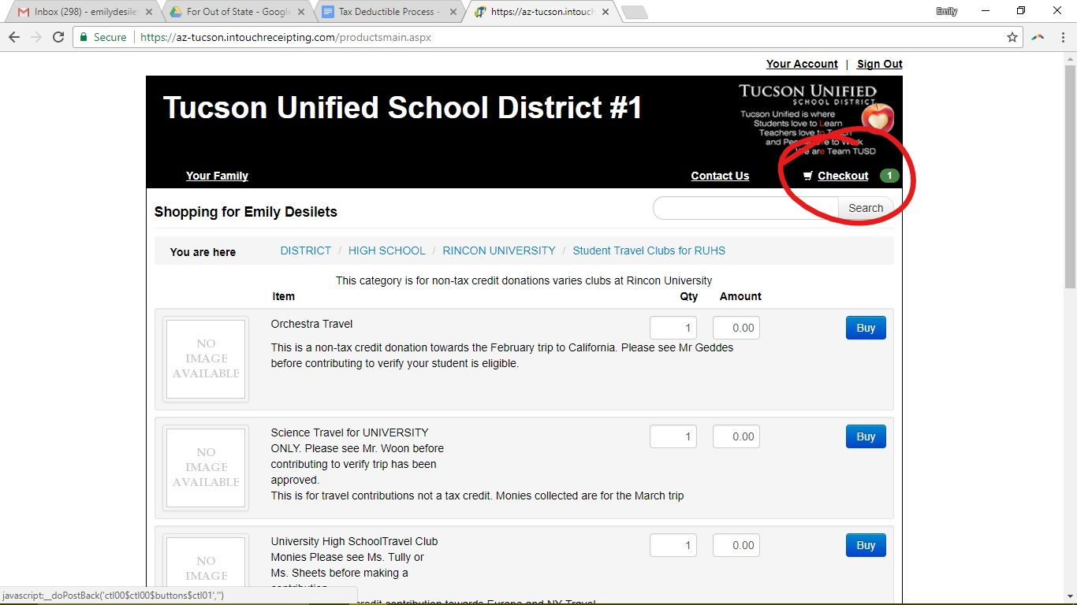
8) This should bring you to your cart. Double check the information given and make sure you’re donating what you want before moving on. Once you are sure about your price and confirm it is going to University High School Travel Club, click “Checkout” on the bottom right hand corner of the screen.
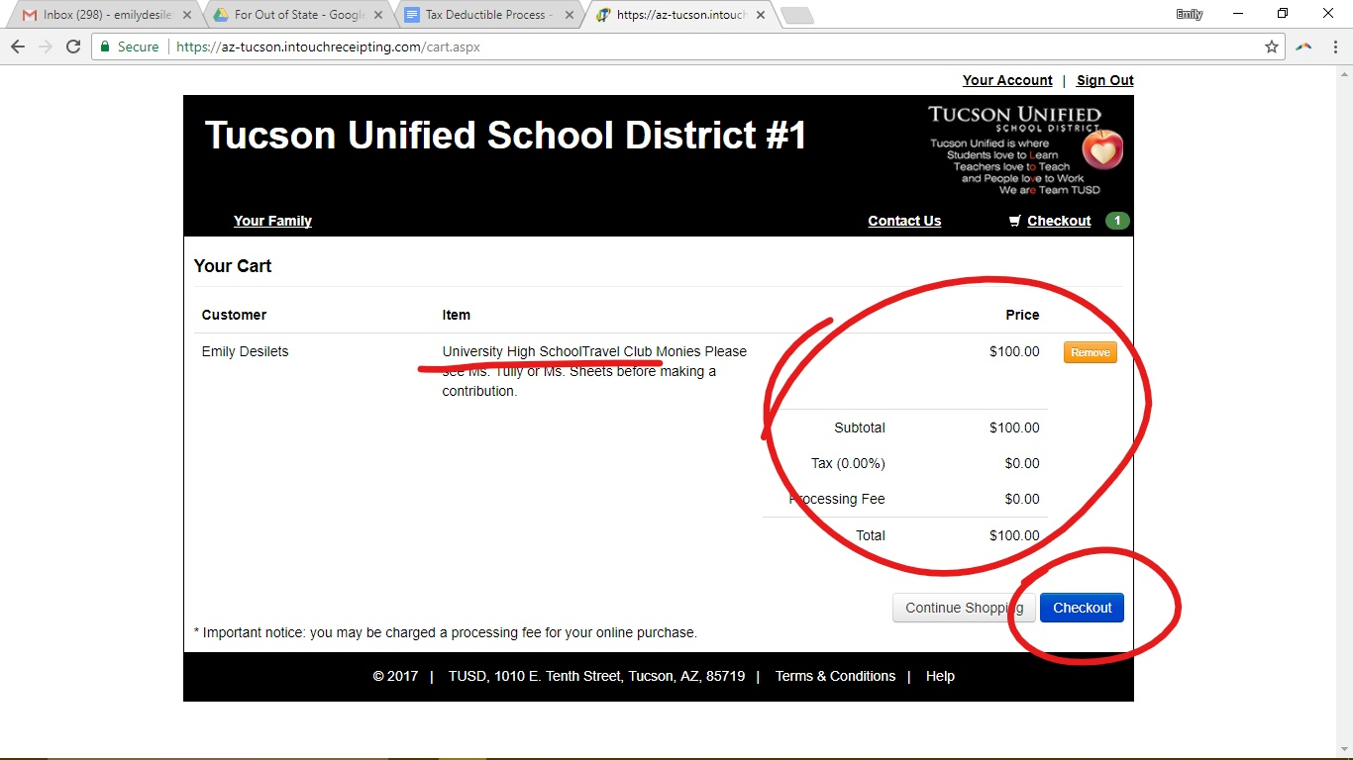
9) In checkout, enter your information accordingly and select “Pay Now”.
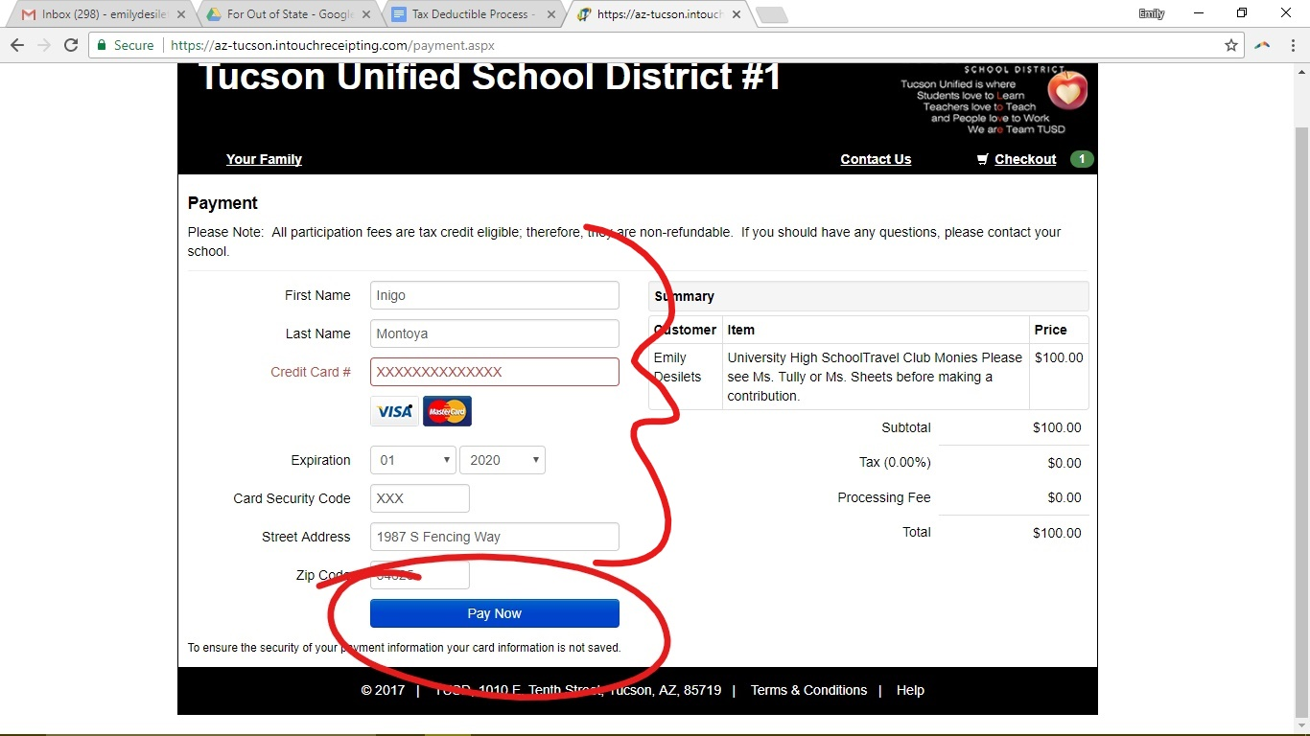

10) Lastly, you should then be brought to a page like this:
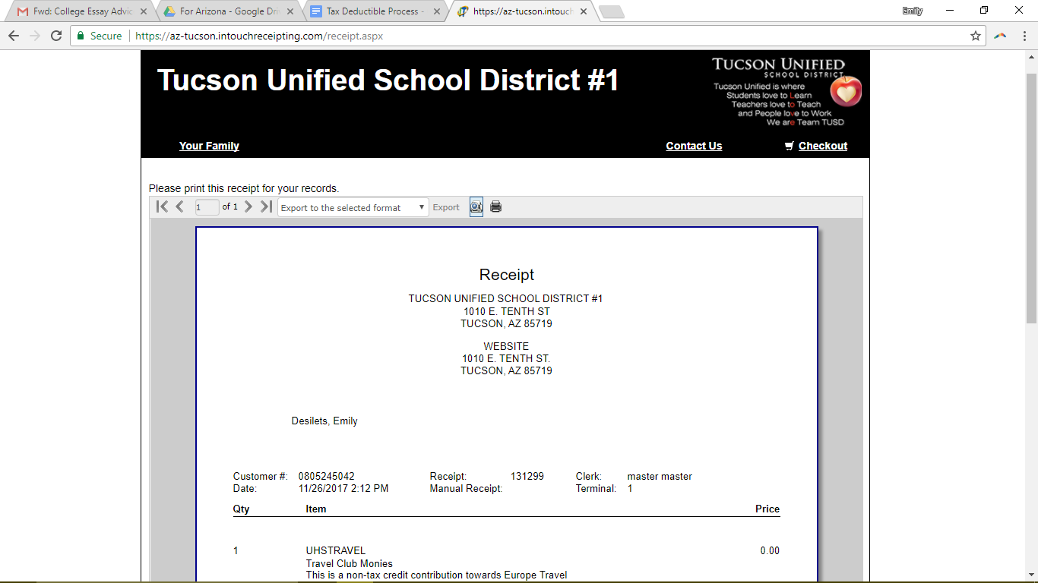
To make sure the money you donate reaches me, you must email me this receipt. In order to do so, you can download it as a pdf. To do this, first choose “Acrobat (PDF) file” under the “Export to the selected format” tab.
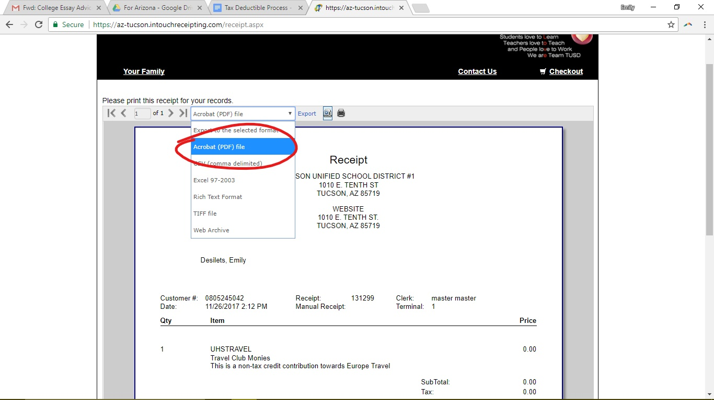

Then Click the word “Export” in blue and it will download the receipt onto your computer as a pdf.
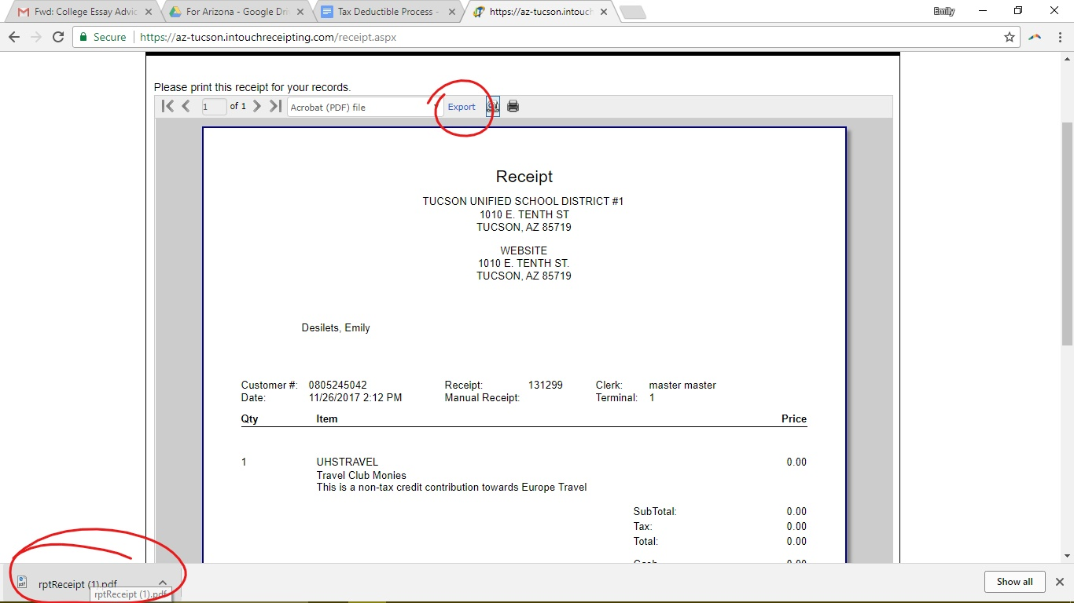
Be sure to email me at emilydesilets16@gmail.com with the receipt attached.

